**Relationships among abundances of juvenile Tanner crabs, spawning adult female crabs, and environmental covariates in the eastern Bering Sea**

Jonathan I. Richar1, Michael A. Litzow1 and Gordon H. Kruse2

We investigated hypotheses concerning the effects of spawning female abundance and a suite of environmental covariates on recruitment of juvenile Tanner crabs, *Chionoecetes bairdi*, in the eastern Bering Sea (eastern Bering Sea). Hypotheses about causal relationships were tested using generalized least squares and generalized additive modeling procedures. We found robust statistically significant (p < 0.05) negative relationships between juvenile crab recruitment and spawning female crab abundance using a linearized Ricker stock-recruit model. Generalized additive modeling suggested an additional negative effect by flathead sole biomass, and a positive relationship with the Pacific Decadal Oscillation. Our findings suggest that parental stock size, groundfish predation and long-term environmental conditions may influence year-class strength for the EBS Tanner crab stock. Interpretation of stock-recruit results is hampered by possible influences of long-term autocorrelated environmental factors and inherent bias introduced due to very high juvenile recruitment observations that coincide with low reproductive stock sizes.

**Key words:** Climate, *Chionoecetes bairdi*, eastern Bering Sea, recruitment, stock-recruit relationship, Tanner crab

**Running head:** Tanner crab recruitment mechanisms

1National Marine Fisheries Service, Alaska Fisheries Science Center, Kodiak Laboratory, 301 Research Court, Kodiak, Alaska 99615, USA. Correspondence to J.I. Richar; email: [jon.richar@noaa.gov](mailto:jon.richar@noaa.gov)

2University of Alaska Fairbanks, College of Fisheries and Ocean Sciences, Department of Fisheries, 17101 Point Lena Loop Road, Juneau, Alaska 99801, USA.

**Introduction**

The brachyuran Tanner crab, *Chionoecetes bairdi*, has supported a lucrative commercial fishery in the eastern Bering Sea (EBS) since the 1960s. However, this stock has also experienced strong variability in recruitment and adult biomass. This has led to a “boom and bust” fishery, with peak landings of 30,209 t in 1977 and 18,189 t in 1990, followed by crashes leading to multiple fishery closures over the intervening decades (Rugolo & Turnock 2011, Stockhausen 2020). This variability in stock size and fisheries outcomes underscores the need to better understand the factors regulating productivity in the stock. The need for increased understanding of stock productivity has been accentuated given that the EBS has experienced a series of extreme marine heatwaves which have been formally attributed to anthropogenic causes (Laufkötter et al., 2020; Walsh et al., 2018). Climate change results in the borealization of Arctic communities, in particular through the introduction of generalist groundfish predators (Frainer et al., 2017; Kortsch et al., 2015), and predation on juvenile snow crab by boreal groundfish has been implicated in the apparent collapse of EBS snow crab (*C. opilio*; Szuwalski et al. 2020). The effects of predation and climate change on EBS crab recruitment are long-standing research topics (e.g., Zheng & Kruse 2006, Thorson et al. 2021), and the ongoing borealization of the underscores the need for better understanding of these effects.

Mechanisms affecting the survival of Tanner crabsfrom age 0 to age 3 are likely to exert the most significant effects on recruitment to the adult stock (Tyler & Kruse 1997). Accordingly, early life history stages have been a focus of previous studies attempting to unravel the causes of fluctuations in crab abundance (Livingston 1989, Rosenkranz et al. 1998, 2001). A putative 13-14 year cycle in both legal-sized male recruitment to the fishery and total adult population size has been interpreted to indicate that long-term cyclicity in the biophysical environment may mediate recruitment strength (Zheng & Kruse 1998, 2003). This putative cycle is also approximately double the mean age of maturity of female Tanner crabs in this region, suggesting the possibility of an endogenous rhythm associated in some way with a stock-recruit (S-R) relationship (Zheng & Kruse 1998).

Previous studies indicated a weak Ricker-style dome-shaped relationship between parental stock size and subsequent recruitment to the adult population at lags of 7-9 yr, though large year-classes resulted from both small and large breeding stocks (Zheng & Kruse 1998, 2003). Several issues hinder the ability to determine S-R relationships. First, the relatively long time lags between reproduction and recruitment increase the potential for confounding by secondary mechanisms. Second, the lack of age structures leads to uncertainty about the time from hatching to recruitment; absence of direct ageing necessitates inferences from modal analysis of size frequency distributions of a cohort observed repeatedly over time (e.g., Donaldson et al. 1981). Finally, owing to environmental and genetic variability in growth rates, members of multiple cohorts may recruit to the adult population within a given year and members of a given cohort recruit over multiple years (Rosenkranz 1998). The use of a smaller (younger) size class of crabs than used to date as an index of recruitment may be an important step in limiting the effects of such concerns, and identifying potential recruitment controls.

A number of biotic and abiotic environmental factors may influence juvenile crab survival. Snow crab, particularly mature females, co-occur with Tanner crab near the Pribilof Islands, and to a greater degree, to the northwest. Given larval advection patterns (Parada et al. 2009, 2010, Richar et al. 2014) and similar ecological niches, it is probable that juveniles of the two species compete where their settling regions overlap. Larval advection is itself largely driven by Ekman transport, due to generally sluggish tidal currents over the EBS shelf, and thus wind patterns may be an important determinant of juvenile survival (Rosenkranz et al. 1998, 2001).Predation by groundfish, in particular Pacific cod *(Gadus macrocephalus)*, and flathead sole *(Hippoglossoides elassodon)* may be a significant source of mortality for juvenile Tanner crabs, as these species consume immature crab in large quantities (Livingston 1989, Pacunski et al. 1998, Lang et al. 2003, 2005). Stomach contents suggest that Pacific cod alone may remove up to 95% of age-1 crab in some years, while also feeding on age 0 and 2 crab at lesser rates (Livingston 1989).

Ocean temperature may also be an important driver of juvenile survival (Paul et al. 1979, Incze 1983, Incze et al. 1982, Incze and Paul 1983, Paul and Paul 2001, Ciannelli and Bailey 2005, Spencer 2008). Surface temperatures may influence zoeal feeding environment, and developmental rate, and thus the period of vulnerability to direct predation while planktonic. Furthermore, environmental temperatures may lead to direct larval mortality when thermal tolerances are exceeded (Paul et al. 1979, Incze 1983, Incze et al. 1982, Incze and Paul 1983). Similarly, near bottom temperature (NBT) may influence post-settlement development rates, modulating vulnerability to predators, while also influencing predator access via thermal barriers, and driving mortality directly via crab thermal tolerances (Paul and Paul 2001, Ciannelli and Bailey 2005, Spencer 2008).

Large scale climatic indices, which may serve as proxies for multiple intertwined environmental variables have proven to be useful in understanding recruitment patterns of certain species (Menge et al. 2011, Tzeng et al. 2012, Harford et al. 2017, Litzow et al. 2018, Szuwalski et al. 2021). Two important indices in the EBS region are the Arctic Oscillation (AO), and the Pacific Decadal Oscillation (PDO). The AO, defined as the leading mode of Northern Hemisphere sea level pressure poleward of 20° N, indexes the north-south range of the jet stream, and may be used as an indicator of mid- and high-latitude temperatures, and storm activity (Thompson and Wallace 1998). The Pacific Decadal Oscillation, defined as the leading mode of North Pacific sea surface temperature (SST) anomalies and may also serve as an indicator for water temperatures, and again storm activity and related wind patterns and strength (Newman et al. 2016). Given the parameters these indices capture, either, or both may influence Tanner crab recruitment through regulation of sea surface and near-bottom temperatures, sea ice melt timing and water column stability and thus feeding environment, and larval advection patterns (Paul et al. 1979, Incze 1983, Incze et al. 1982, Incze and Paul 1983, Rosenkranz et al. 1998, Paul and Paul 2001, Rosenkranz et al. 2001, Ciannelli and Bailey 2005, Spencer 2008). Significantly, a recent study using assessment model recruitment estimates has linked the AO to recruitment variability in both snow crab and Bristol Bay red king crab, although not Tanner crab (Szuwalski et al. 2021).

In this study we examined the factors regulating juvenile Tanner crab abundance as measured by a bottom trawl survey over the period of 1978-2019. Specifically, we evaluated the effects of spawning stock size, competition (as indexed by female opilio abundance), predation (as indexed by the abundance of two groundfish predators, Pacific cod and flathead sole and a suite of physical variables (wind patterns, the PDO, AO, NBT, SST).

**Methods**

Tanner Crab Abundance Estimates

Tanner crabdata from an annual bottom trawl survey of the EBS continental shelf conducted by the National Marine Fisheries Service (NMFS) over 1978-2019 were provided by the NMFS Alaska Fisheries Science Center (AFSC). During the first decade, there was a gradual expansion of the survey area leading to variability in the number of stations sampled. The survey extent was standardized in 1988, and 376 stations have been consistently sampled annually since. A 0.5-hr tow is made near the center of each 20 x 20 nmi2 (37 x 37 km2) square on a sampling grid. Since 1982, the standardized sampling gear has been an eastern otter trawl using an 83 ft (25.m) head rope and a 112 ft (34.1 m) footrope (Rugolo & Turnock 2011, Zacher et al. 2020).

For purposes of our analysis, we defined juvenile crab as those of both sexes with a carapace width (CW) of 30-50 mm. Crabs in this size range are likely predominately 3 years old, based on size-at-age relationships estimated for Tanner crabs in the Gulf of Alaska (Donaldson et al. 1981) corrected for the greater intermolt period in the colder temperatures of the EBS (Paul & Paul 2001). To account for possible error in age estimates we also considered the possibility that 30-50 mm CW crabs were predominantly 2 or 4 yr old, for sensitivity analysis in our initial S-R models. Use of design-based estimates for this size range and at this lag is an important distinction relative to Szuwalski et al. (2021), who used model recruitment estimates at a lag of 5 yrs in their work, increasing the potential for confounding of effects.

Mature female Tanner crabs were defined as females of shell condition 3 (SC3, old shell). Tanner crab experience a terminal molt upon reaching sexual maturity. Shell-age classification approximates the time since the last molt using criteria described by Jadamec et al. (1999). Shell condition 2 female crabs were ignored in our study as these are likely to be primiparous crabs. These have an extended brooding period, mating in late winter immediately following the terminal molt and carrying the resultant embryos until the following year (Swiney 2008). Consequently, primiparous females sampled in year *t* will hatch their eggs in year *t+1* andwill not contribute to the hypothesized age 3 juvenile pseudocohort in year *t+3* used as the response variable in our S-R analyses. Exploratory models showed that S-R results were not appreciably different whenshell condition 4 (SC4) females were excluded, consequently this class was excluded from analysis, as they may have lower fecundity. Finally, SC5 crabs (very, very old shell) were ignored due to comparatively high rates of barrenness, lower fecundity and low abundance.

For both juveniles, and mature female crabs, average catch-per-unit-effort (CPUE) for size/SC class *k* in year *i* for strata *s* (${\overline{C}}_{ksi}$) was calculated as:

${\overline{C}}_{ksi}=\frac{\sum_{s}{\sum_{j}{\frac{{\sum_{k}{f}}_{jk}}{A_{j}}}}}{n_{si}}$, (eq. 1)

where $f_{jk}$ = the estimated sampling factor for crabs in size/SC class *k* at station *j*, used to account for subsampling based on sex, size and SC in the case of large hauls, $a_{ji}$ = the estimated area swept at station *j* in year *i*, in terms of km2 and *nsi*= the number of stations sampled in strata

Annual area swept abundance estimates for a given class *k* in year *i* ($N_{ki}$) were then calculated as:

$N_{ki}=\sum_{i}{{\overline{C}}_{ksi}*a_{si},}$ (eq. 2)

where $N_{ki}$ is the area swept abundance estimate for class k year *i*, ${\overline{C}}_{ksi}$ is the mean station CPUE for strata *s* in year *i*, and $a_{si}$ is the area of strata *s* in year *i*.

Environmental covariates

Data for hypothesized environmental covariates (Table 1) were obtained from multiple sources. As with the Tanner indices, data for ovigerous female snowcrab were obtained from the AFSC survey database, and estimates were calculated using eqs (1, 2). Near bottom temperature (NBT) measurements were also obtained from the survey database, and annual averages were calculated across all hauls. Three-year rolling averages were then calculated on the final year used for the given rolling average i.e. for an average of temperatures in years *y*, *y*-1 and *y*-2, the rolling average estimate was credited to year *y*.

Data for the Arctic Oscillation and Pacific Decadal Oscillation (PDO) were obtained from <https://www.ncdc.noaa.gov/teleconnections/>. We used winter data for the PDO (December- February mean for the year corresponding to January). Winter values of the AO, were calculated as January- March means. Three-year rolling averages were then calculated for each index using the same procedures as applied for NBT. May – June Sea surface temperature (SST MJ), estimates were obtained from the Extended Reconstructed Sea Surface Temperature (ERSST) v5 dataset (Huang et al. 2017), available from <https://www.ncdc.noaa.gov/data-access/marineocean-data/extended-reconstructed-sea-surface-temperature-ersst-v5>. Estimates for the months of May, June and July and corresponding to the EBS region were extracted, and averaged annually. Finally, northeastern and southeastern wind vector components during the summer (May-September) were resolved via analysis of v- and u-components from the NCAR-NCEP database, obtained from <http://apdrc.soest.hawaii.edu/erddap/griddap/>, and averaged by year.

For groundfish, population estimates were taken from recent stock assessment model results for Pacific cod (Thompson and Thorson, 2019), and flathead sole (McGilliard et al. 2019). For Pacific cod, we used abundance estimates for ages 3-7 only, because cod of size 30-59 cm, generally corresponding to these ages, feed more heavily on juvenile Tanner crab than those ≥ 60 cm (Livingston 1989). Three-year rolling averages were then calculated as per procedures used for previous covariates. For flathead sole, we considered the minimum age likely capable of feeding on juvenile Tanner crab based on mean fish length-at-age (McGilliard et al. 2019), estimated maximum gape size based on visual comparison of mouth and body sizes, and mean crab size-at-age (Rugolo & Turnock 2011). Based on these considerations, we used estimated total biomass for age 3+ flathead sole to represent the age groups capable of consuming juvenile Tanner crab.

Analysis

To evaluate potential autocorrelation in recruitment, the sample autocorrelation function (ACF) was plotted for lags of 0 to 14 yr for three time stanzas: 1978-2008, 2009-2019 and 1978-2019. The break between the first two stanzas was based on previous unpublished work, for which this study was a followup (Richar and Kruse, unpublished). That earlier study focused on the period 1978-2008: here we sought to repeat those analyses, while also updating them with more recent data. Significant positive autocorrelations were indicated at lag 1 yr for all stanzas, and for the 1978-2008 stanza only, a significant negative autocorrelation at lag 6 yr. Therefore, a first‑order auto-regressive process was employed in exploratory generalized least squares (GLS) regression modeling of the stock-recruit (S-R) relationship, using the *R* package *nlme*, and with the structure:

ε*t* = φ ε*t*-1 + ν*t* , (eq. 3)

where ν*t* is assumed to be Gaussian white noise at time *t*, NID(0, σ2ν), and φ is the autocorrelation parameter such that at lag *t*-1, -1 < < 1, and σ2{ε*t*} = .

The stock-recruit relationship was modeled using the log-transformed, linearized Ricker model:

$\ln\left(\frac{R}{S}\right)= α+ βS+ε_{t}$, (eq. 4)

Where R is estimated recruitment, S is the corresponding properly lagged spawner estimate, α and β are model estimated parameters and *εt* is as previously described. To assess significance while allowing autocorrelation, and to test robustness of the S-R relationship across multiple lags, exploratory S-R models using this structure were run using GLS procedures at lags of 2, 3 and 4 yrs between the female abundance index, and the juvenile recruitment index.

Based on these exploratory analyses, follow-up analyses were conducted using Generalized Additive Modeling (GAM) procedures using the *R* package *mgcv* to model the S-R relationship in the presence of multiple environmental covariates, though not incorporating corrections for autocorrelation:

$\ln\left(\frac{R}{S}\right)= α+ƒ_{1}\left(S\right)+ƒ_{2}\left(X_{2}\right)+…+ε$ (eq. 5)

Where α is the intercept/productivity term, ƒ is a smooth function with a user-specified number of degrees of freedom *R* and *S* are as before, the *Xi* are environmental covariates and ε is a normally distributed error term.

To begin, a baseline model with only a stock-recruit effect was specified, then iterated on via forward model selection, whereby variable are progressively added with each iteration. In addition, two modified models with only an S-R effect, one with a reduced period length, matching the time period for which data are available for flathead sole, and the other dividing the model into two eras matching the first two stanzas examined using the ACF (1978-2008 and 2009-2019) were considered. Environmental covariates were lagged relative to recruitment to the juvenile index based on their hypothesized mechanism (Table 1). Where multiple covariates were included in one model, care was taken to ensure that they were not themselves correlated (Table 2). Model performances were assessed using small sample-size Akaike Information Criterion (AICc) calculated with the R package MuMIn (Barton 2020). All analyses were conducted using R version 4.0.3 (R Core Team 2020).

**Results**

Juvenile Tanner crab recruitment was characterized by large interannual variability, with peaks and troughs occurring at roughly decadal intervals (Fig 1). Longer periods in population cycles were observed prior to 2000, than in the following decades. Associated with this change in cycle periodicity, a statistically significant 7-year period negative autocorrelation observed prior to 2005 disappears afterwards (Figs 2a and 2b). Female abundance also displays periodic fluctuations, with peak abundances observed during the earlier years of the 1980s and 1990s, though magnitudes were reduced relative to juvenile estimates, particularly in more recent years (Fig. 3).

A density-dependent S-R relationship is suggested by a curvilinear relationship between estimated juvenile abundance and reproductive females (Fig. 4). This is reinforced by a statistically significant Ricker stock-recruit relationship were observed in the corresponding GLS model (Table 2), with both productivity and density-dependent terms being significant, while autocorrelation was also notable (Table 2). Plots of the S-R residuals across time demonstrate a cyclical pattern that the S-R relationship does not capture, suggesting influence by an external factor within the environment (Fig. 4). Results for exploratory lag-2 yr and lag 4-yr models were similar to those for the primary lag-3 yr models (Table 3).

Fitting of GAMs combining an S-R effect and one or more environmental covariates demonstrated the continuing importance of the S-R effect in all models investigated (e.g. Figs 5, 6, 7). Based on AICc values, the best model, improving on its closest competitor by 5 points, incorporated the S-R effect, flathead sole TBM and the winter PDO (Table 2). Of the environmental covariates, flathead sole total biomass as both a single-yr estimate, and a rolling average, provided the most consistent improvement in model AICc values (Table 4). Inclusion of the winter PDO improved AICc values, both when considered as the only environmental covariate, and when considered in concert with flathead sole total biomass (Table 4). Model structure however affected the nature of the relationship: when modeled as the only environmental covariate a strong positive relationship may be observed between the PDO and juvenile crab recruitment; this changes to a curvilinear relationship, with an initial positive slope that plateaus with the addition of flathead sole TBM (Fig. 5).

Sea surface temperature did not significantly improve model explanatory power over models without it (Table 4). Furthermore, inclusion of the SST MJ term lead to a curvilinear “S” relationship between flathead sole and juvenile crab recruitment, which is not considered plausible (Fig. 6). Although ovigerous female opilio improved model performance, an inverted curvilinear, or “dome”, relationship was observed with Tanner juvenile recruitment (Fig. 7). Given the ecology of these two species, and the proposed mechanism (competition), this relationship is not plausible, and likely to be spurious. Consequently, we did not further explore this variable. Finally, both wind vector components, with their associated Ekman advection, Pacific cod abundance, and 3-yr rolling averages of both NBT and the AO either failed to improve model performance, or offered minimal improvement (Table 4).

**Discussion**

Our results suggest the presence of a density-dependent S-R relationship for the Tanner crab population in the EBS with cyclical variability around the long-term trend. Furthermore, we found evidence of a predator-prey relationship with flathead sole biomass, and environmentally mediated survival driven by sea surface temperature during late spring and early summer, and winter values of the PDO.

Similarly to Zheng & Kruse (1998, 2003), we found variability consistent with a 13-14 year cycle in both recruitment and total adult population size, which is approximately double the mean generation time (2T) of female Tanner crabs in this region. Interestingly though, this cycle seems to have broken down in the years after 2005, suggesting a change in recruitment mechanisms.

Cyclical patterns of recruitment are not uncommon among brachyuran crabs. For instance, abundance of age 0+ snow crabs (*Chionoecetes opilio*) fluctuated periodically with stronger year-classes recurring approximately every 7 yr in the EBS (Ernst et al. 2012, Burgos et al. 2013) and 8 yr in the northwest Gulf of St. Lawrence in eastern Canada (Sainte-Marie et al. 1996, Émond et al. 2015). This cycle length is equivalent to the time interval between a female crab’s conception (zygote) and her terminal molt and first spawning, i.e., one mean generation time (1T). On the other hand, along the US west coast, Dungeness crab (*Cancer magister*) tend to cycle with a period of 10 yr, corresponding to 2T for this species (Botsford and Hobbs 1995).

Cyclical recruitment patterns equal to 1T, such as the case for snow crab, may arise from a phenomenon termed “cohort resonance” (Burgos et al. 2013, Émond et al. 2015), typical of some semelparous populations (e.g., Pacific salmon, *Oncorhynchus* sp., Worden et al, 2010) whereby cohorts interact with each other (e.g., through cannibalism and/or intraspecific competition), and their interactions with the environment and fishing pressure (Bjørnstad et al. 2004, Botsford et al. 2014). For such species, lifetime reproduction decreases, and recruitment variability increases, with increased levels of fishing (Botsford et al., 2011). Moreover, these changes in variability are tied to sensitivity to fluctuations in the ocean environments at generational frequencies (tied to species life history), and changes in low frequency variations independent of life history (Botsford et al, 2011, 2014). Snow crab populations in the EBS and northwest Gulf of St. Lawrence are considered quasi-semelparous as primiparous females (first time spawners) contribute the most to recruitment in both areas (Émond et al. 2015).

However, cycles with a period of 2T, as described for Dungeness crab and as we describe here for Tanner crab, may arise primarily through over-compensatory density dependence (Botsford et al. 2014). Such density-dependent effects may result from several mechanisms. Synchronized release of larvae by dense aggregations of female crab may create dense patches of first-feeding zoeae that compete for prey (Stevens et al. 1994). Although there are no direct observations of this behavior in the EBS, as there are for the Gulf of Alaska (Stevens et al. 1994), high-density stations encountered during bottom trawl surveys are consistent with this behavior. It is thus reasonable to expect that in the relatively sluggish currents over the EBS continental shelf, larvae may maintain dense aggregations (Stabeno et al. 2001). To successfully feed, larval Tanner crab require high densities of copepods, potentially exceeding the mean concentration typically experienced in much of the natural environment (Paul et al. 1979, Incze & Paul 1983). In years of high reproductive output, we can speculate that zoeae in dense aggregations may thus experience increased mortality rates due to starvation as they deplete the local copepod population through feeding (Paul et al. 1979). The positive relationships observed between recruitment and both SST and the PDO are consistent with this hypothesis, as these mechanisms are expected to improve copepod production as their values increase (Hunt et al. 2002, Hunt and Stabeno 2002, Hunt et al. 2022).

Finally, our density-dependent effect findings may also be explained by the fact that high population densities may also lead to significantly increased disease prevalence, increasing natural mortality rates, particularly in the high-density aggregations often observed in juvenile crabs. In the EBS region, the dinoflagellate *Hematodinium*, also known as bitter crab disease (BCD) infects *Chionoecetes* *spp*. crabs, leading to mortality rates of up to 100% (Meyers et al. 1996). Although all life stages may be infected, current evidence suggests that females and juvenile crab are the most susceptible to infection, likely due, at least in part, to increased molting frequencies, particularly for juveniles (Pestal et al. 2003, Shields et al. 2005).

Our work provides support for the hypothesis of a predation effect in the case of flathead sole, with a negative relationship observed between juvenile recruitment and flathead sole biomass. This is consistent with observations that flathead sole are second only to Pacific cod in terms of Tanner crab predation; and are occasionally the top predator of Tanner crab, based on stomach contents (Lang et al. 2005). A significant relationship was not however found between Pacific cod and Tanner crab recruitment. This outcome is in accordance with a previous retrospective analysis, which found no significant negative relationship between cod and crab recruitment in the eastern (Bristol Bay) area (Rosenkranz 1998). On the contrary, analysis of cod stomachs indicated intense predation by young cod on Tanner crab, particularly for crab of age 1 yr (Livingston 1989), which has been corroborated by more recent analyses (Livingston et al. 1993, Lang et al. 2005). Of interest here, in work exploring cod densities at model-simulated larval settling locations, it was found that cod densities were much higher at these locations in the early-mid 1980s, coincident with the seminal work by Livingston (1989), than they have been for much of the time since. Elucidation of potential relationships between cod and Tanner crab may depend on spatial considerations. For instance, in a recent analysis, cod was the strongest predictor of changes in the longitude of Tanner crab centroids of abundance; that is, when cod biomass is high, Tanner crab tend to be distributed farther offshore (Szuwalski et al., 2020).

Complexities present in predator-prey relationships may confound the ability to detect significant relationships in retrospective analyses such as ours. The degree of overlap between predator and prey may vary interannually, as both populations respond to interactions between dynamic environmental conditions and their respective environmental tolerances, with this reflected in predatory pressure experienced by the prey species (Ciannelli and Bailey 2005, Spencer 2008). If non-specialist predators experience a glut of prey items of various species, feeding pressure on a particular species might be reduced due to prey switching as predators optimize their foraging success (Krivan 1996). In addition, predator-prey relationships can be mediated through indirect effects by the presence of another predator (Siddon & Witman 2004), thus altering the observed functional response. Consequently, absence of an apparent predatory effect here should not be considered as conclusive evidence of a lack of a groundfish predation effect on recruitment strength of juvenile Tanner crab.

Contrary to previous studies (Rosenkranz et al. 2001), the results from this project do not offer strong support for the hypothesis of an effect by mean-bottom temperature on juvenile survival and recruitment. Conversely, our findings for sea surface temperature were generally in accordance with prior studies, which were inconclusive once autocorrelation was adjusted for (Rosenkranz 1998). Our one exception to this occurred in models where SST was paired with flathead sole TBM (Table 4). In this case, plotting of the data suggests the presence of a modest positive effect (Figure 6).

The expectation of a positive relationship between SST and recruitment was based on two hypothesized mechanisms:

1.) Predation during the zoeal stage would be significant, such that enhanced zoeal rates o growth and maturation associated with warmer temperatures would increase survival through reduced exposure to predation

2.) Tanner zoeae feed on smaller copepod species (i.e. *Oithona* spp. and *Pseudocalanus* spp.), which are believed to benefit from warmer SST due to increased reproductive and growth rates, and would thus be expected to also benefit from increased food supplies (Coyle and Pinchuk 2002).

The potential relationship observed is consistent with the proposed mechanisms, suggesting that colder temperatures may alter growth rates, such that differential predation levels are experienced. This is supported by the findings of Kon (1979), that in the zoeae of *C. opilio*, a species that is cold-adapted (Parada et al. 2009, Parada et al. 2010), growth rates were markedly reduced by exposure to colder temperatures. It would seem reasonable to expect that if a cold adapted congener experiences reduced growth rates in colder conditions, then the more warm-adapted Tanner would as well.

Ocean temperature can significantly influence interannual variability in the eastern Bering Sea zooplankton community (Coyle and Pinchuk 2002). Numerically dominant small-bodied copepods, including *Pseudocalanus* and *Oithona* appear to be strongly influenced by ocean temperature, with key life history parameters, including growth and reproduction appearing to be more strongly affected by this than by food availability, with both appearing enhanced by warm temperatures (Smith and Vidal 1984). The nauplii of these species have been hypothesized to comprise a major portion of the diet of zoeal Tanner crab, with this assertion being based on size of the nauplii and the reproductive rate and abundance of the adults (Incze et al. 1987). Incze and Paul (1983) noted that 1st feeding *bairdi* zoeae required high densities of copepods to be able to feed successfully. In another study, Paul et al. (1979) examined effects of food density on larval survival, finding that in the absence of food, zoeae experienced 100% mortality within 8 days, while larval survival scaled with increasing concentration of food: treatments with the highest food concentrations also had the highest zoeal survival rates (Paul et al. 1979).

The Pacific Decadal Oscillation (PDO) comprises a decadal scale pattern of variability in SST values in the central North Pacific, driven by atmospheric variability, particularly in the strength and position of the Aleutian Low during the winter, and a range (Newman et al. 2016). . The PDO is an important indicator for conditions in the Bering Sea, particularly SST, and a shift in the winter PDO in 1977 has been linked to a large-scale community reorganization throughout the North Pacific region. During a positive phase in the PDO, SST anomalies are positive in the Bering Sea region while during a negative phase the regional SST anomaly is negative.

If the SST results previously discussed are valid, then they may provide an explanation for the observed relationship through this relationship to EBS regional SST. Furthermore, as the PDOs is associated with the Aleutian Low, it is indicative of atmospheric circulation patterns which may themselves influence surface currents, and thus potentially, larval advection patterns. Thus, an additional explanation for the results of this study is that wind patterns associated with the positive phase of the summer PDO are deleterious to larval retention on the outer shelf.

Our research faced several complications related to our juvenile crab data. First, there is uncertainty in determining age of the crabs, as all hard structures that might be used for age determination are lost during molting. Due to variability in growth, it is also not possible to accurately infer individual ages based on carapace width. We judged that a majority of crab in the 30-50 mm CW size range would be age 3 yr based on size-at-age data for the Kodiak area in the northern Gulf of Alaska (Donaldson et al. 1981), coupled to recognition that colder temperatures are likely to be less favorable for growth in the EBS compared to the Gulf of Alaska. Finally, the survey sampling gear is size-selective for adult and subadult crab; younger, smaller crabs are not fully represented in the catch (Somerton & Otto 1999). Differences between the magnitudes of our juvenile and subsequent adult estimates were however consistent with current estimates of natural mortality (*M* = 0.23), while juvenile crab abundance exhibited trends similar to those experienced by the adult population 2-4 yr. later. Therefore, we feel that our juvenile abundance estimates are reasonable.

We anticipate that the greatest promise for future research into environmental recruitment factors lies in recruitment investigations that consider the spatial scales at which the regulating processes operate. Detailed comparisons of spatial distributions of juvenile Tanner crab, together with those of key limiting ecological factors, may be essential to more completely understand recruitment mechanisms that likely operate on finer-than-regional spatial scales and which likely vary interannually with changing oceanographic conditions. This approach may also resolve discrepancies in predation studies between stomach content analyses and statistical analyses, such as reported here.

**References**

Barton, K. 2020. MuMIn: Multi-Model Inference. R package version 1.43.17. <https://CRAN.R-project.org/package=MuMIn>

Bjørnstad ON, Nisbet RM, Fromentin FM (2004) Trends and cohort resonant effects in age-structured populations. J Anim Ecol 73: 1157-1167.

Bond NA, Harrison DE. 2000. The Pacific Decadal Oscillation, air-sea interaction and central north Pacific winter atmospheric regions. Geophysical Research Letters 27: 731-734.

Botsford, L. W., and Hobbs, R. C. 1995. Recent advances in the understanding of cyclic behavior of Dungeness crab (*Cancer magister)* populations. ICES Mar Sci Symp 199: 157-166.

Botsford LW, Holland MD, Field JC, Hastings A (2014) Cohort resonance: a significant component of fluctuations in recruitment, egg production, and catch of fished populations. ICES J Mar Sci 71: 2158-2170.

Botsford, L. W., Holland, M. D., Samhouri, J. F., White, J. W., and Hastings, A. 2011. Importance of age structure in models of the response of upper trophic levels to fishing and climate change. ICES J Mar Sci 68: 1270–1283.

Burgos J, Ernst B, Armstrong D, Orensanz JM (2013) Fluctuations in range and abundance of snow crab (*Chionoecetes opilio*) from the eastern Bering Sea: What role for Pacific cod (*Gadus macrocephalus*) predation? Bull Mar Sci 89: 57-81

Ciannelli L, Bailey KM (2005) Landscape dynamics and resulting species interactions: the cod-capelin system in the southeastern Bering Sea. Mar Ecol Prog Ser 291: 227-236.

Coyle KO, Pinchuk AI. 2002. Climate-related differences in zooplankton density and growth on the inner shelf of the southeastern Bering Sea. Progress in Oceanography 55: 177-194.

Dai P, Tan B. 2017. The nature of the Arctic Oscillation and diversity of the extreme surface weather anomalies it generates. Journal of Climate 30: 5563-5584.

Donaldson WE, Cooney RT, Hilsinger JR (1981) Growth, age and size at maturity of Tanner

crab, *Chionoecetes bairdi* M.J. Rathbun, in the northern Gulf of Alaska. J Crustac Res 40: 286-302.

Émond, K., Sainte-Marie, B., Galbraith, P. S., and Beˆty, J. Top-down vs. bottom-up drivers of recruitment in a key marine invertebrate: investigating early life stages of snow crab. ICES Journal of Marine Science, 72: 1336–1348.

Ernst B, Armstrong DA, Burgos J, and Orensanz JM (2012) Life history schedule and periodic recruitment of female snow crab (*Chionoecetes opilio*) in the eastern Bering Sea. Can. J. Fish. Aquat. Sci. Can. J. Fish. Aquat. Sci. 69: 532–550.

Frainer, A., Primicerio, R., Kortsch, S., Aune, M., Dolgov, A. V, Fossheim, M., & Aschan, M. M. (2017). Climate-driven changes in functional biogeography of Arctic marine fish communities. *PROCEEDINGS OF THE NATIONAL ACADEMY OF SCIENCES OF THE UNITED STATES OF AMERICA*, *114*(46), 12202–12207. <https://doi.org/10.1073/pnas.1706080114>.

Haddon, M (2001) Modeling and quantitative methods in fisheries. Chapman & Hall/CRC, FL.

Harford, WJ, Karnauskas M, Walter JF, Liu H. 2017. Non-parametric modeling reveals environmental effects on Bluefin tuna recruitment in Atlantic, Pacific and Southern Oceans. Fish Oceanogr 26:396-412.

Hunt Jr. GL, Stabeno PJ. 2002. Climate change and the control of energy flow in the southeastern Bering Sea. Progress in Oceanography 56: 5-22.

Hunt Jr GL, Stabeno P, Walters G, Sinclair E, Brodeur RD, Napp JM, Bond NA. 2002. Climate change and control of the southeastern Bering Sea pelagic ecosystem. Deep Sea Research II 49: 5821-5853

Hunt Jr GL, Yasumiishi EM, Eisner LB, Stabeno PJ, Decker MB. 2022. Climate warming and the loss of sea ice: the impact of sea-ice variability on the southeastern Bering Sea pelagic ecosystem. ICES Journal of Marine Science 79: 937-953.

Incze LS (1983) Larval life history of Tanner crabs, *Chionoecetes bairdi* and *C. opilio*, in the southeastern Bering Sea and relationships to regional oceanography. Ph.D. thesis. University of Washington.

Incze LS, Armstrong DL, Wenker DL (1982) Rates of development and growth of larvae of *Chionoecetes bairdi* and *C. opilio* in the southeastern Bering Sea. In: Proceedings of the international symposium on the genus *Chionoecetes*. University of Alaska, Alaska Sea Grant Rep. 82-10, p 191-218.

Incze LS, Paul AJ (1983) Grazing and predation as related to energy needs of stage 1 zoeae of the tanner crab *Chionoecetes bairdi* (brachyuran, Majidae) Biol Bull165:197-208.

Jadamec LS, Donaldson WE, Cullenberg P (1999) Biological field techniques for *Chionoecetes* crabs. University of Alaska Sea Grant College Program, AK-SG-99-02.

Kon T. 1979. Ecological studies on larvae of the crabs belonging to the genus Chionoecetes-I The influence of starvation on the survival and growth of the zuwai crab. Bull Japanese Society of Scientific Fisheries 45:7-9.

Kortsch, S., Primicerio, R., Fossheim, M., Dolgov, A. V, & Aschan, M. (2015). Climate change alters the structure of arctic marine food webs due to poleward shifts of boreal generalists. *PROCEEDINGS OF THE ROYAL SOCIETY B-BIOLOGICAL SCIENCES*, *282*(1814), 31–39. https://doi.org/10.1098/rspb.2015.1546.

Krivan V (1996) Optimal foraging and predator-prey dynamics. Theo Pop Biol 49: 265-290.

Lang GM, Derrah CW, Livingston PA (2003) Groundfish food habits and predation on commercially important prey species in the eastern Bering Sea from 1993 through 1996. U.S. Dep. Commer, AFSC Processed Report 2003-04, 352 p.

Lang GM, Livingston PA, Dodd KA (2005) Groundfish food habits and predation on commercially important prey species in the eastern Bering Sea from 1997 through 2001. U.S. Dep. Commer. NOAA Tech Memo NMFS-AFSC-158, 230 p.

Laufkötter, C., Zscheischler, J., & Frölicher, T. L. (2020). High-impact marine heatwaves attributable to human-induced global warming. *SCIENCE*, *369*(6511), 1621+. https://doi.org/10.1126/science.aba0690

Litzow MA, Ciannelli L, Puerta P, Wettstein JJ, Rykaczewski RR, Opiekun M. 2018. Non-Stationary climate-salmon relationships in the Gulf of Alaska. Proc R Soc B. 285: 20181855.

Livingston PA (1989) Interannual trends in Pacific cod, Gadus macrocephalus, predation on three commercially important crab species in the eastern Bering Sea. Fish Bull 87: 807-827.

McGilliard CR, Nichol D, Britt L. 2019. Assessment of the flathead sole-Bering flounder stock in the Bering Sea and Aleutian Islands. North Pacific Fishery Management Council, Anchorage, Alaska. 6p.

Menge BA, Gouhier TC, Freidenberg T, Lubchenco J. 2011. Linking long-term, large-scale climatic and environmental variability to patterns of marine invertebrate recruitment: Toward explaining “unexplained” variation. J Exp Mar Biol Ecol 400: 236-249.

Newman, M., Alexander, M. A., Ault, T. R., Cobb, K. M., Deser, C., Di Lorenzo, E., Mantua, N. J., Miller, A. J., Minobe, S., Nakamura, H., Schneider, N., Vimont, D. J., Phillips, A. S., Scott, J. D., & Smith, C. A. (2016). The Pacific Decadal Oscillation, revisited. *Journal of Climate*, *29*, 4399–4427. https://doi.org/10.1175/JCLI-D-15-0508.1.

North Pacific Fishery Management Council (NPFMC) (2011) Fishery management plan for Bering Sea/Aleutian Islands king and Tanner crabs. North Pacific Fishery Management Council, Anchorage, Alaska.

Pacunski RE, Livingston PA, Miller BS (1998) Food of flathead sole *Hippoglossoides elassodon* in the eastern Bering Sea. U.S. Dep. Commer. NOAA Tech Memo NMFS-AFSC-90, 27 p.

Parada C, Ernst B, Hinckley S, Orensanz JM, Armstrong DA, Curchitser E, Hermann AJ. 2009. Patterns in connectivity and potential settlement regions of snow crab (Chionoecetes opilio) larvae in the eastern Bering Sea. Progress in Oceanography

Parada C, Armstrong DA, Ernst B, Hinckley S, Orensanz LM (2010) Spatial dynamics of snow crab *(Chionoecetes opilio)* in the eastern Bering Sea – Putting together the pieces of the puzzle. Bull Mar Sci 86:413-437.

Paul AJ, Paul JM, Shoemaker PA, Feder HM (1979) Prey concentrations and feeding response in laboratory-reared stage-one zoeae of king crab, snow crab and pink shrimp. Trans Am Fish Soc 108:440-443.

Paul AJ, Paul JM (2001) Effects of temperature on length of intermolt periods in juvenile male *Chionoecetes bairdi*. Alaska Fish Res Bull 8:132-134.

Pestal GP, Taylor DM, Hoenig JM, Shields JD, Pickavance R. 2003. Monitoring the prevalence of the parasitic dinoflagellate *Hematodinium sp*. in snow crabs *Chionoecetes opilio* from Conception Bay, Newfoundland. Diseases of Aquatic Organisms 53: 67-75.

R Core Team. 2020. R: A language and environment for statistical computing. R Foundation for Statistical Computing, Vienna, Austria. URL <https://www.R-project.org>.

Richar, J, Kruse, G., Curchitser, E. and Hermann, AJ. 2014. Patterns in connectivity and retention of simulated Tanner crab (Chionoecetes bairdi) larvae in the eastern Bering Sea. Progress in Oceanography 138: 475-485.

Rosenkranz GE (1998) Statistical modeling of Tanner crab recruitment in Bristol Bay, Alaska. M.S. Thesis. University of Alaska Fairbanks.

Rosenkranz GE, Tyler AV, Kruse GH, Niebauer HJ (1998) Relationship between wind and year class strength of Tanner crabs in the southeastern Bering Sea. Alsk Fish Res Bull 5:18-24.

Rosenkranz GE, Tyler AV, Kruse GH (2001) Effects of water temperature and wind on year-class success of Tanner crabs in Bristol Bay, Alaska. Fish Oceanogr10:1-12.

Rugolo L, Turnock J (2011) 2011 Stock assessment and fishery evaluation report for the Tanner crab fisheries of the Bering Sea and Aleutian Islands regions. In: Stock assessment and fishery evaluation report for the king and Tanner crab fisheries of the Bering Sea and Aleutian Islands regions, 2011 Crab SAFE. North Pacific Fishery Management Council, Anchorage, Alaska, p 285-354.

Sainte-Marie, B, Sévigny JM, Smith BD, Lovrich GA (1996) Recruitment variability in snow crab (Chionoecetes opilio): pattern, possible causes, and implications for fishery management. In High Latitude Crabs: Biology, Management, and Economics, Program Report AK-SG-96-02, pp. 451–478. Alaska Sea Grant College, Anchorage, AK.

Sainte-Marie B, Lafrance M (2002) Growth and survival of recently settled snow crab *Chionoecetes opilio* in relation to intra- and intercohort competition and cannibalism: a laboratory study. Mar Ecol Prog Ser 244:191-203.

Sainte-Marie B, Goselin T, Sévigny JM, Urbani N. 2008. The snow crab mating system: opportunity for natural and unnatural selection in a changing environment. Bull Mar Sci 83: 131-161.

Shields JD, Taylor DM, Sutton SG, O’Keefe PG, Ings DW, Pardy AL. 2005. Epidemiology of bitter crab disease (*Hematodinium sp.*) in snow crabs *Chionoecetes opilio* from Newfoundland, Canada. Diseases of Aquatic Organisms 64: 253-264.

Shields JD, Taylor DM, O’Keefe PG, Colbourne E and Hynick E. 2007. Epidemiological determinants in outbreaks of bitter crab disease (*Hematodinium sp.*) in snow crabs *Chionoecetes opilio* from Conception Bay, Newfoundland, Canada. Diseases of Aquatic Organisms 77: 61-72.

Siddon CE, Witman JD (2004) Behavioral indirect interactions: multiple predator effects and prey switching in the rocky subtidal. Ecology 85:2938-2945.

Smith SL, Vidal J. 1984. Spatial and temporal effects of salinity, temperature, and chlorophyll on the communities of zooplankton in the southeastern Bering Sea. Journal of Marine Research 42: 221-257.

Somerton DA, Otto RS. 1999. Net efficiency of a survey trawl for snow crab Chionoecetes opilio, and Tanner crab, C. bairdi. Fish Bull 97: 617-625.

Spencer PD (2008) Density-independent and density-dependent factors affecting temporal changes in spatial distributions of eastern Bering Sea flatfish. Fish Oceanogr 17: 396-410.

Stabeno PJ, Bond NA, Kachel NB, Salo SA, Schumacher JD. 2001. On the temporal variability of the physical environment over the south-eastern Bering Sea. Fisheries Oceanography 10: 81-98.

Stevens BG, Haaga JA, Donaldson WE (1994) Aggregative mating of Tanner crabs, *Chionoecetes bairdi*. Can J Fish Aquat Sci 51:1273-1280.

Stockhausen, WT (2020) 2020 Stock assessment and fishery evaluation report for the Tanner crab fisheries of the Bering Sea and Aleutian Islands regions. In: Stock assessment and fishery evaluation report for the king and Tanner crab fisheries of the Bering Sea and Aleutian Islands Regions, 2020 Final Crab SAFE. North Pacific Fishery Management Council, Anchorage, Alaska.

Swiney KM (2008) Egg extrusion, embryo development, timing and duration of eclosion, and incubation period of primiparous and multiparous Tanner crabs (*Chionoecetes bairdi*). J Crustac Biol 28: 334-341.

Szuwalski C (2020) A stock assessment for eastern Bering Sea snow crab. In: Stock assessment and fishery evaluation report for the king and Tanner crab fisheries of the Bering Sea and Aleutian Islands Regions, 2020 Final Crab SAFE. North Pacific Fishery Management Council, Anchorage, Alaska.

Thompson DWJ and Wallace JM. 1998. The Arctic oscillation signature in the wintertime geopotential height and temperature fields. Geophysical Research Letters 25: 1297-1300

Thompson GG, Thorson JT. 2019. Assessment of the Pacific cod stock in the eastern Bering Sea. NPFMC Bering Sea and Aleutian Islands SAFE. North Pacific Fishery Management Council, Anchorage, Alaska. 271p.

Thorson JT, Arimitsu MA, Barnett LAK, Cheng W, Eisner LB, Haynie AC, Hermann AJ, Holsman K, Kimmel DG, Lomas MW, Richar J, Siddon EC. 2021. Forecasting community reassembly using climate-linked spatio-temporal ecosystem models. Ecography 44: 612-625.

Tyler AV, Kruse GH (1997) Modeling workshop on year-class strength of Tanner crab, *Chionoecetes bairdi.* Alaska Department of Fish and Game. Regional Information Report No. 5J97-02, Juneau, Alaska.

Tzeng W-N, Tseng Y-H, Han Y-S, Hsu C-C, Chang C-W, Di Lorenzo E, et al. (2012) Evaluation of Multi-Scale Climate Effects on Annual Recruitment Levels of the Japanese Eel, Anguilla japonica, to Taiwan. PLoS ONE 7(2): e30805. https://doi.org/10.1371/journal.pone.0030805.

Walsh, J. E., Thoman, R. L., Bhatt, U. S., Bieniek, P. A., Brettschneider, B., Brubaker, M., Danielson, S., Lader, R., Fetterer, F., Holderied, K., Iken, K., Mahoney, A., McCammon, M., & Partain, J. (2018). The high latitude heat wave of 2016 and its impacts on Alaska. *Bulletin of the American Meteorological Society*, *99*(1, S), S39--S43. https://doi.org/10.1175/BAMS-D-17-0105.1

Worden, L, Botsford LW, Hastings A, Holland MD (2010) Frequency responses of age-structured populations: Pacific salmon as an example. Theoret Popul Biol 78: 239–249.

Zacher, LS, Richar JI, Foy RJ. 2020. The 2019 eastern and northern Bering Sea continental shelf trawl surveys: Results for commercial crab species. U.S. Dep. Commer., NOAA tech. memo. NMFS-AFSC-400, 234 p.

Zacher, LS, Richar JI, Litzow MA. 2021. The 2021 eastern Bering Sea continental shelf trawl surveys: Results for commercial crab species. U.S. Dep. Commer., NOAA tech. memo. Draft version.

Zheng J, Kruse GH (1998) Stock-recruitment relationships for Bristol Bay Tanner crabs. Alsk Fish Res Bull 5:116-130.

Zheng J, Kruse GH (2003) **Stock-recruitment relationships for three major Alaskan crab stocks.** Fish Res 65:103-121.

Zheng J, Kruse GH (2006) Recruitment variation of eastern Bering Sea crabs: Climate forcing or top-down effects? Prog Oceanogr 68:184-204.

|  |  |  |  |  |
| --- | --- | --- | --- | --- |
| Covariate | Lag prior to recruitment | Crab life stage | Relationship | Mechanism |
| Ovigerous female opilio | 3 yr | Zoeae-juvenile | (-) | Interspecific competition |
| Pacific cod - 3 yr rolling average | 1 yr | Megalopae-age 2 yr juvenile | (-) | Predation |
| Flathead sole | 2 yr | 1st year juvenile | (-) | Predation |
| Flathead sole - 2 yr rolling average | 1 yr | 1st and 2nd yr juveniles | (-) | Predation |
| Arctic oscillation 3-yr rolling average | 1 yr | Zoeae-age 2 yr juvenile | (+) | Feeding and growth |
| NBT - 3 yr rolling average | 1 yr | Megalopae - age 2 juvenile | (+) | Growth/thermal tolerances |
| SST-May to July average | 3 yr | Zoeae | (+) | Feeding/growth |
| PDO - 3 yr rolling average | 1 yr | Zoeae-age 2juvenile | (+) | Feeding/growth/thermal tolerances |
| SE wind | 3 yr | Zoeae | (+) | Larval retention |
| NE wind | 3 yr | Zoeae | (-) | Reduced larval retention |

Table 1. Environmental covariates used in GAM modeling, lag applied to value, crab life stage affected, hypothesized relationship, and proposed mechanism. For rolling averages, note that average is applied to final year of set used to calculate a given value.

|  |  |  |  |  |  |  |  |  |  |  |  |
| --- | --- | --- | --- | --- | --- | --- | --- | --- | --- | --- | --- |
|  | Bairdi females | Pacific cod | FHS TBM RA3 | FHS TBM | Opilio females | PDO RA3 | SST MJ | AO RA3 | NBT RA3 | SE wind | NE wind |
| Bairdi females | 1.00 | -0.06 | 0.02 | 0.02 | 0.35 | -0.18 | 0.01 | 0.56 | -0.07 | 0.01 | -0.37 |
| Pacific cod | -0.06 | 1.00 | -0.45 | -0.45 | -0.07 | -0.28 | -0.54 | -0.27 | -0.17 | -0.07 | 0.00 |
| FHS TBM RA3 | 0.02 | -0.45 | 1.00 | 0.90 | 0.36 | -0.18 | 0.34 | 0.37 | -0.02 | 0.09 | 0.06 |
| FHS TBM | 0.02 | -0.45 | 0.90 | 1.00 | 0.35 | -0.14 | 0.38 | 0.34 | 0.11 | 0.02 | 0.04 |
| Opilio females | 0.35 | -0.07 | 0.36 | 0.35 | 1.00 | -0.30 | -0.15 | 0.51 | -0.09 | -0.13 | -0.17 |
| PDO RA3 | -0.18 | -0.28 | -0.18 | -0.14 | -0.30 | 1.00 | 0.38 | -0.22 | 0.43 | -0.17 | -0.02 |
| SST MJ | 0.01 | -0.54 | 0.34 | 0.38 | -0.15 | 0.38 | 1.00 | 0.09 | 0.50 | -0.07 | -0.23 |
| AO RA3 | 0.56 | -0.27 | 0.37 | 0.34 | 0.51 | -0.22 | 0.09 | 1.00 | 0.08 | 0.03 | -0.01 |
| NBT RA3 | -0.07 | -0.17 | -0.02 | 0.11 | -0.09 | 0.43 | 0.50 | 0.08 | 1.00 | 0.04 | 0.20 |
| SE wind | 0.01 | -0.07 | 0.09 | 0.02 | -0.13 | -0.17 | -0.07 | 0.03 | 0.04 | 1.00 | 0.35 |
| NE wind | -0.37 | 0.00 | 0.06 | 0.04 | -0.17 | -0.02 | -0.23 | -0.01 | 0.20 | 0.35 | 1.00 |

Table 2. Correlations among investigated biophysical variables.

|  |  |  |  |
| --- | --- | --- | --- |
|  | Lag 2 | Lag 3 | Lag 4 |
| Intercept | 1.93 (<0.001) | 2.32 (<0.001) | 2.23 (<0.001) |
| S | -1.43e-08 (<0.001) | -3.15e-08 (<0.001) | -2.78e-08 (<0.001) |
| phi | 0.75 | 0.62 | 0.54 |

Table 3. Generalized least squares stock-recruit model output. Parameter estimates and associated p-values for linearized Ricker stock-recruit models by lag. Phi values denote strength of autocorrelation.

|  |  |  |  |
| --- | --- | --- | --- |
| Model | AICc | Delta AICc | Model variables |
| 15 | 83.79 | 2.06 | CB females, SST MJ |
| 1 | 81.73 | 0 - baseline | CB females |
| 5 | 81.37 | -0.36 | CB females, 3 yr rolling average of Pacific cod |
| 3 | 79.65 | -2.08 | CB females (1978-2005. 2006 to 2019) |
| 2 | 67.91 | -13.82 | CB females (1983 and later) |
| 17 | 65.5 | -16.23 | CB females, PDO 3-yr rolling average |
| 7 | 65.46 | -16.27 | CB females (1983 and later), flathead sole TBM 2 yr rolling average |
| 4 | 64.79 | -16.94 | CB females, ovigerous CO females |
| 14 | 64.53 | -17.2 | CB females, flathead sole TBM, SST May-July (GLS model) |
| 11 | 63.48 | -18.25 | CB females, flathead sole TBM, AO 3-yr rolling average |
| 9 | 63.38 | -18.35 | CB females, NE wind |
| 10 | 62.92 | -18.81 | CB females, SE wind |
| 8 | 61.83 | -19.9 | CB females,flathead sole TBM |
| 12 | 61.29 | -20.44 | CB females, flathead sole TBM, NBT 3-yr rolling average |
| 6 | 60.93 | -20.8 | CB (1983 and later) flathead sole TBM |
| 13 | 60.57 | -21.16 | CB females, flathead sole TBM, SST May-July |
| 16 | 55.64 | -26.09 | CB females, flathead sole TBM, PDO 3-yr rolling average |

Table 4. Model output for GAM models. CB = Bairdi, CO = opilio, TBM = total biomass, NBT = near bottom temperature, SST = sea surface temperature. For model #14, FHS TBM was incorporated as a linear variable.

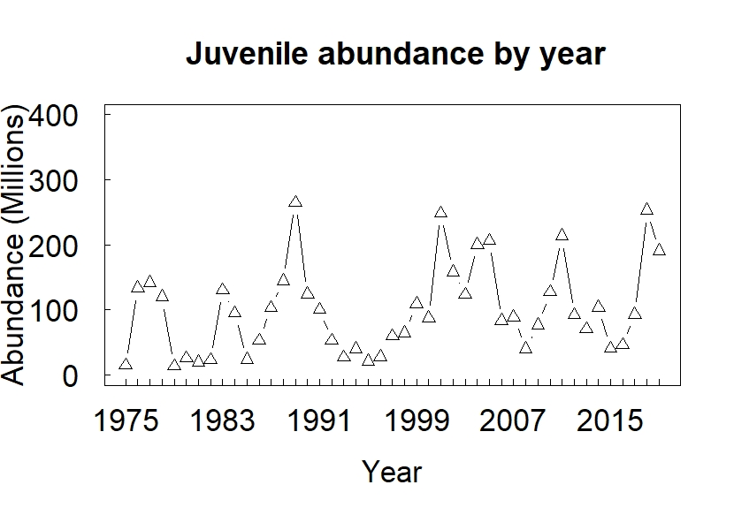

Figure 1. Juvenile abundance time series.

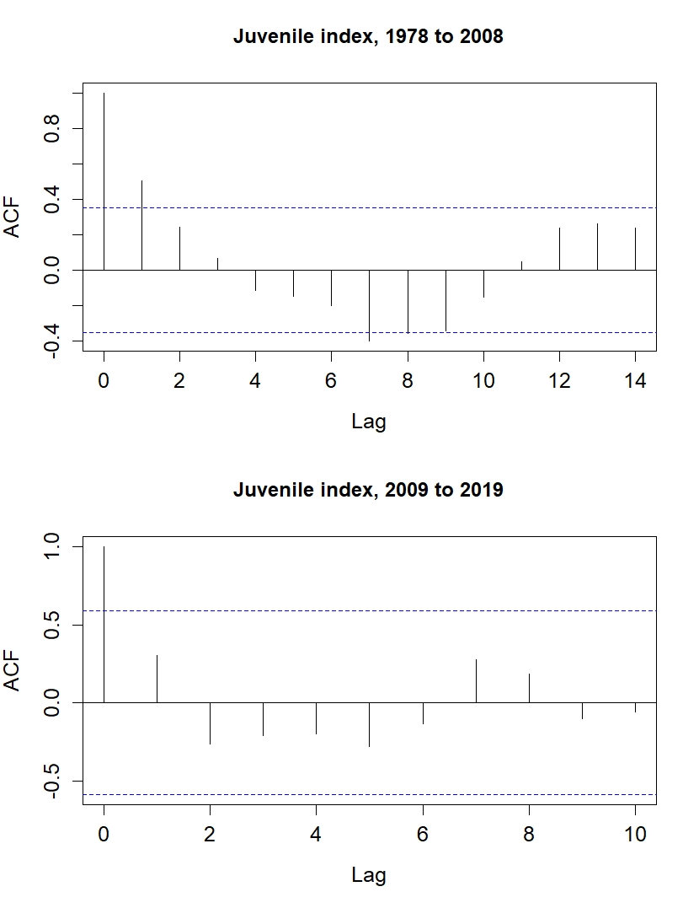

Figure 2. Juvenile abundance time series autocorrelation function (ACF) plots. Note statistically significant negative autocorrelation present at lag = 7 in first stanza, which becomes positive and non-significant during second.

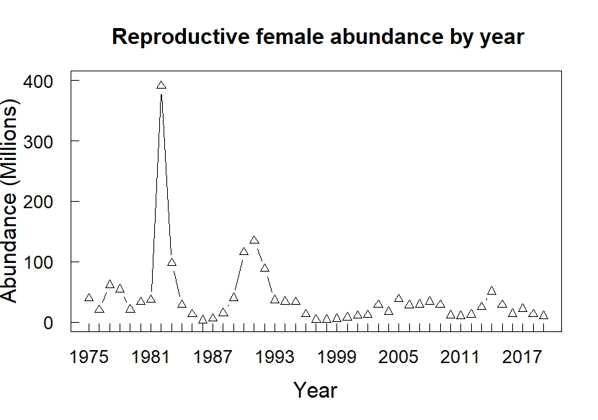

Figure 3. Female abundance time series. Note extreme estimate in 1982, which likely resulted from sampling issues, and along with matched 1985 juvenile estimate was removed for analysis.

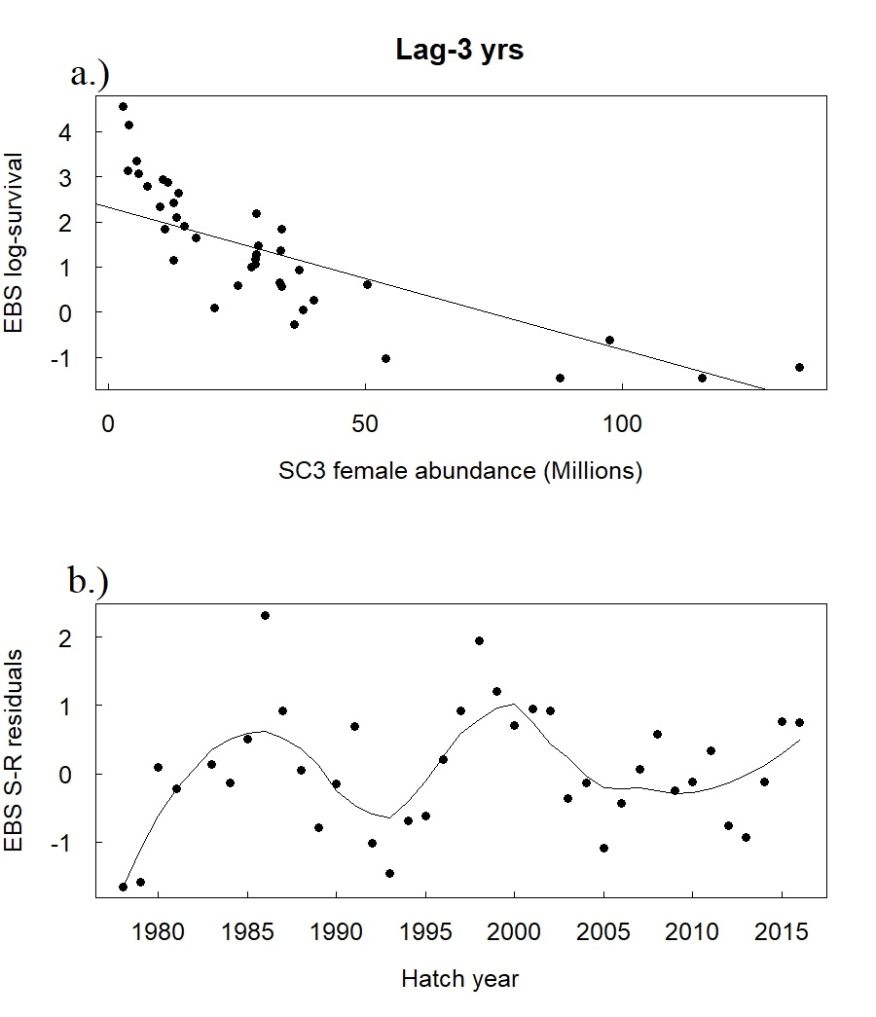

Figure 4. Lag-3 yr stock-recruit results: a) log-survival vs shell condition 3 (SC3) female estimates: b) stock-recruit model residuals.

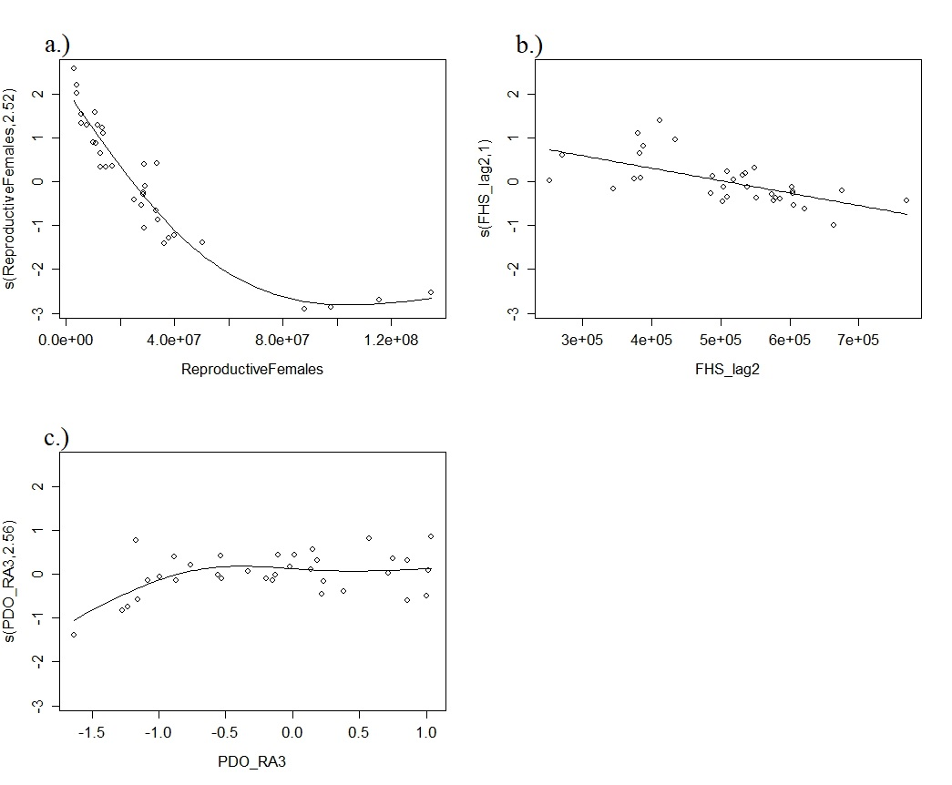

Figure 5. Graphical output for generalized additive model combining stock-recruit relation with flathead sole (FHS) and a 3 yr rolling average (RA3) of the winter Pacific Decadal Oscillation (PDO) as the environmental covariates.

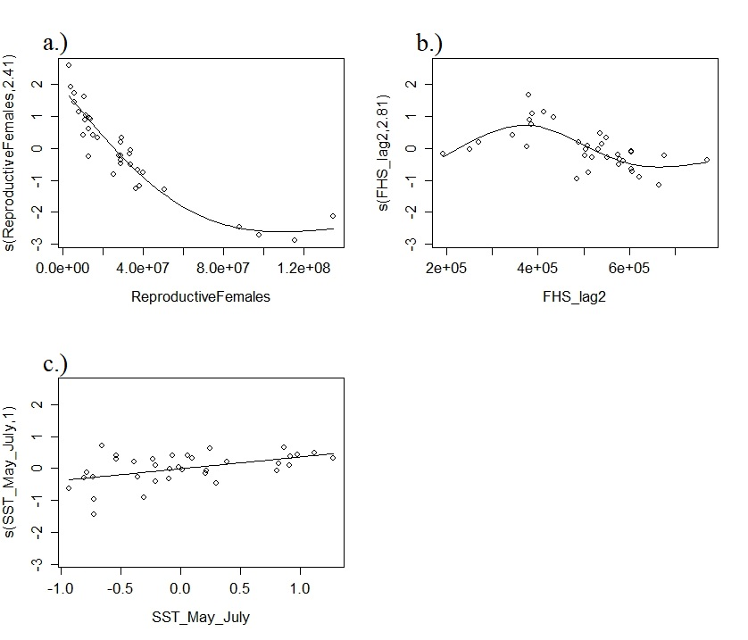

Figure 6. Graphical output for generalized additive model combining stock-recruit relation with flathead sole (FHS) and average sea surface temperature (SST) during the period May - July as the environmental covariates. Note the implausible curvilinear relationship for FHS.

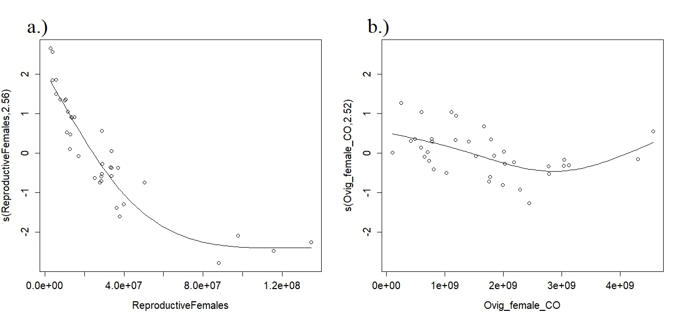

Figure 7. Graphical output for generalized additive model combining stock-recruit relation with ovigerous female opilio abundance as the environmental covariate, with larval/juvenile crab competition as the proposed mechanism.